Internship Houseekeeping
DEPARTEMENTS: Housekeeping
STARTING DATE: 2026

About Cardo Brussels Hotel
Welcome to Cardo Brussels, where hospitality meets fun! Located within the heart of Europe, Cardo Brussels is a lifestyle destination like nothing else, providing hospitality with a sense of self through unique design, playful personality and ironic character.
The hotel offers 532 stylish rooms including a unique collection of 46 suites, as well as 1500m2 of MICE facilities and amenities (16 meetings rooms, 1 ball room, 3 restaurants & bars ….), and features a rooftop swimming pool, and a SPA that fully engage the customer.

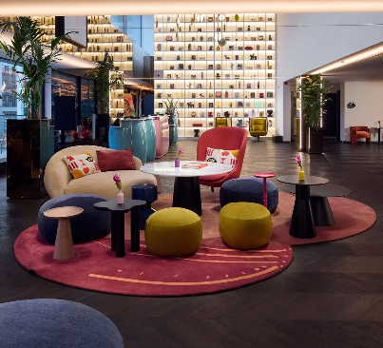



ARE YOU READY FOR?
- an internship at one of Belgium's largest and most unique hotels?
- to grow your skills and kickstart your career in hospitality?
- eager to join Marriott, the global leader in the hospitality industry?

WHAT YOU WILL LEARN / DO
- Gain hands-on experience in the daily housekeeping operations (room readiness, cleaning standards, stock and linen management).
- Support the housekeeping manager and assist the team in day-to-day tasks.
- Contribute to guest satisfaction by managing requests efficiently and ensuring high quality standards.
- Participate in daily reporting, inventory follow-up and planning activities.
- Collaborate on operational improvements and communication flows between departments.

In joining Cardo, you join a portfolio of brands with Marriott International. Be where you can do your best work,​ begin your purpose, belong to an amazing global​ team, and become the best version of you.

ARE YOU OUR NEXT COLLEAGUE ? Who…
- Loves to Help: You’re enthusiastic about supporting your team and making a difference.
- Is Multilingual: Fluent in English, with French and/or Dutch skills.
- Knows Your Way Around Tech: Proficient in MS Office.
- Is Pursuing a Degree: In management, hospitality, or business.
- Has a Passion for Hospitality: You’re excited about the hotel world and eager to learn!
To be considered for an internship, you must have a learning agreement of minimum 4 months from your school or university, and be eligible to work in Belgium.

ADVANTAGES:
- Monthly allowance : 600€
- Meals 8€/Day
- 100% public transportation
- Marriott Employee Rate Program: Every employee (and their family) can benefit from Marriott Bonvoy's discounted rates for nights and meals at Marriott hotels worldwide.

Good news! Join Cardo Team for your internship!
Don’t hesitate, send us your resume now and join our team for this unique career opportunity! jobs.brussels@cardohotels.com

