

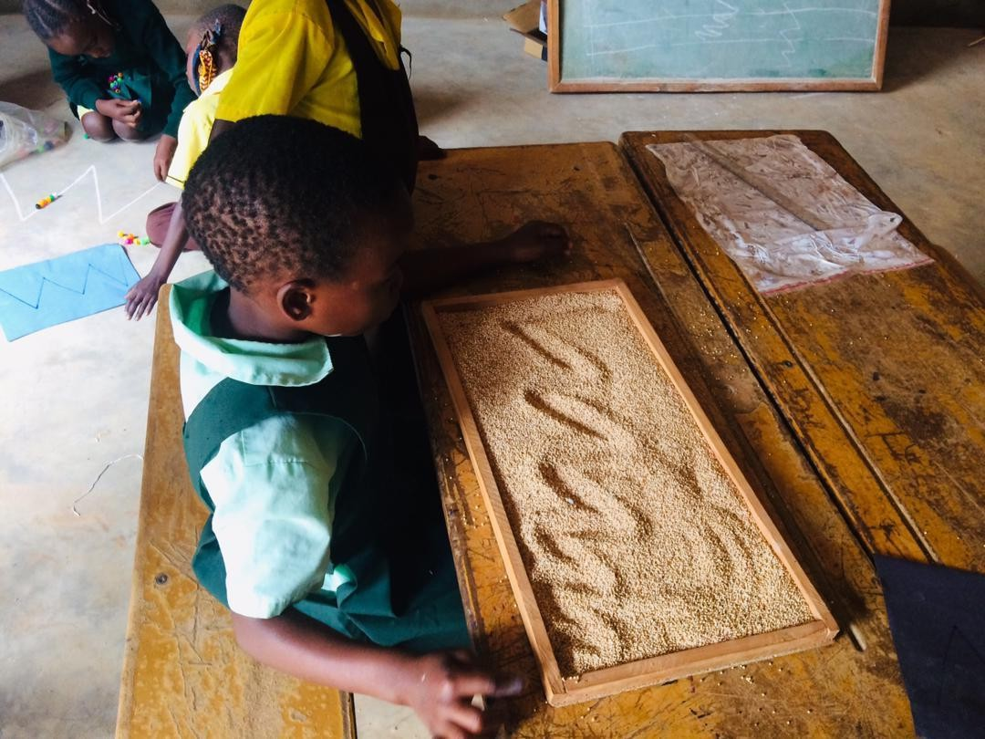


Procurement Officer
Lusaka, Zambia

Deadline for applications: 17th February 2026
Job opportunity – 01/09/2025 Procurement Officer

At VVOB, we realise the importance of focusing on our in-house talent and creating opportunities to retain the potential we have within our organisation.
Therefore, before vacancies are published externally, we open them internally to give our staff the opportunity to apply, to grow and to further develop themselves within VVOB.
Are you interested and eager to find out if you are a fit for this position? Then check the specifications outlined in this vacancy. We are looking for Procurement Officer who will operate from our office in Lusaka.
Do you want to take on this challenge? Continue reading!

Result areas of the Procurement Officer:
- The Procurement Officer plays a very important role in making sure that VVOB pays a fair price for the goods and services that it needs. The Procurement Officer sets out to find suitable vendors/suppliers and negotiate prices by following the VVOB Procurement process. Once selection is made on the vendor/supplier the Procurement Officer will prepared the necessary paperwork and contracts.

- Through building strong relationships with vendors and suppliers the Procurement Officer will develop a list of preferred suppliers.
- VVOB organizes many training activities; the Procurement Officer is therefore an important partner for the Programs team to procure the various elements necessary to organize a successful activity (venue, hotel, transportation, catering etc).

- The Procurement Officer is part of the Operations team and reports to the Operations Manager.

You will be:
- Processing of procurement requests.
- Responsible for preparation of framework agreement with vendors.
- Establish a relationship with preferred vendors/suppliers.
- Responsible for contract management of vendors/suppliers (ensuring contracts and supporting documents are properly stored and accessible for reference when needed).
- Prepare all the CFQs.
- Act as the secretary of the procurement committee.
- Prepare all the Pos
- Reviews of all the asset listings.
- In charge of the vendor listing and management.
- Support with training in logistics for new staff.

If you’re our Procurement Officer, your workweek at the office will include the following highlights:



  - Collaborate with the Project Coordinators and the rest of the team explaining them how to complete the necessary documentation to ensure procurement requests go through the process seamlessly.
  - Lunch! A perfect time to nurture informal relationships with the other team members in Zambia and hear how everyone is doing.

  - You discuss the progress you made on your tasks/responsibilities with the Operations Manager.
  - With your keen eye for detail you cross check the procurement requests before sending them for final approval.

  - Ensure compliance with the organisation’s procurement policies and guidelines and in line with donor requirements.
  - Support non-operations staff through the procurement processes during on boarding of new staff.



Does this look like your dream job?
Then read on and check whether your profile matches the job requirements!

Who are you?
This is a national position, open only to Zambian Nationals.

Your expertise and experience

- Minimum of a bachelor’s degree.
- Experience in procurement/purchasing for a minimum of 3 years.
- Registered with Zambia Institute of Purchasing and Supply
- Strong negotiation skills and relationship building.
- Have an analytical mindset.
- Strong organizational and time management abilities.
- An excellent team player.
- Fluent in English.
- Experience in a non-profit organization is a plus.
- Experience in the international development sector.
- Excellent computer skills in a full range of software, including MS office, such as TEAMS and Outlook, and social tools.
- Excellent communication skills in English, including writing, conversing and presenting.
- Experience with working in a multicultural team.

- All professional and academic qualifications should be verified by ZAQA.

Matching competences

VVOB core competences:
- Result and goal oriented
- Continuous improvement
- Cooperation within a team and other stakeholders

Function specific competencies:
- Creativity
- Development Oriented
- 360° empathy
- Communication skills

What we’re offering:
- A dynamic working environment in an international context.
- An exciting job in a growing organisation with varied responsibilities and opportunities for professional development.
- An opportunity to contribute to exciting, evidence-based projects aimed at ensuring the education sector in Zambia is strengthened, by bringing in innovative solutions for professional development of school leaders and teachers.
- A complete remuneration package, which includes a base salary and benefits.
- A national contract to 31/12/2026 with the possibility of extension subject to funding and performance.
What’s next?
Send your motivation letter detailing your match with the profile as well as your motivation behind applying for the vacancy along with your CV by e-mail no later than 17th February 2026 to jobs.vvob.org/en/procurement-officer. Don’t forget to refer to the job title in the subject line of your e-mail. Before a job offer, shortlisted candidates can expect:
- a written test
- an interview process
VVOB firmly believes that quality education can only be achieved if equity is ensured. Qualities of people prevail, regardless of age, gender, ethnicity or disability. If you require reasonable accommodation including disability accommodation in completing this application, interviewing, completing any pre-employment testing, or otherwise participating in the employee selection process, please direct your inquiries to recruitmentzambia@vvob.org .

Julien Dillensplein 1 bus 2A Belgium VVOB
www.vvob.org VVOB vzw
1060 Brussels info@vvob.org

